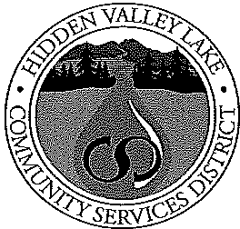Hidden Valley Lake

Community Services District

19400 Hartmann Road
Hidden Valley lake, CA 95467
707.987.9201
707.987.3237 fax www.hiddenvalleylakecsd.com

In preparation of adoption of the 2017-2018 Fiscal Year Budget for the Hidden Valley Lake Community Services District, the Board of Directors will hold a budget workshop on June 13, 2017 at 5:30p.m. The final budget will be presented for approval at the June 20, 2017 regular board meeting at 7:00 p.m. Both meetings will be held in the District's boardroom at 19400 Hartmann Road, Hidden Valley Lake, California.

PLEASE TAKE NOTICE that the Secretary to the Board of the Hidden Valley Lake Community Services District has called a hearing to set forth a resolution for adoption of the 2017-2018 fiscal year budget. The Hidden Valley Lake
Community Services District's Board of Directors will conduct a hearing, including
possible adoption of the 2017-2018 fiscal year budget at the June 20, 2017 regular board meeting at 7:00p.m. at 19400 Hartmann Road, Hidden Valley Lake, California. At that time and place, any interested person, including all persons owning property within the District, may appear and be heard to address the proposed 2017-2018 fiscal year budget.

If you have any questions, please contact the District Office at (707) 987-9201.

Kirk Cloyd, General Manager/Secretary to the Board

Posted: June 8, 2017

