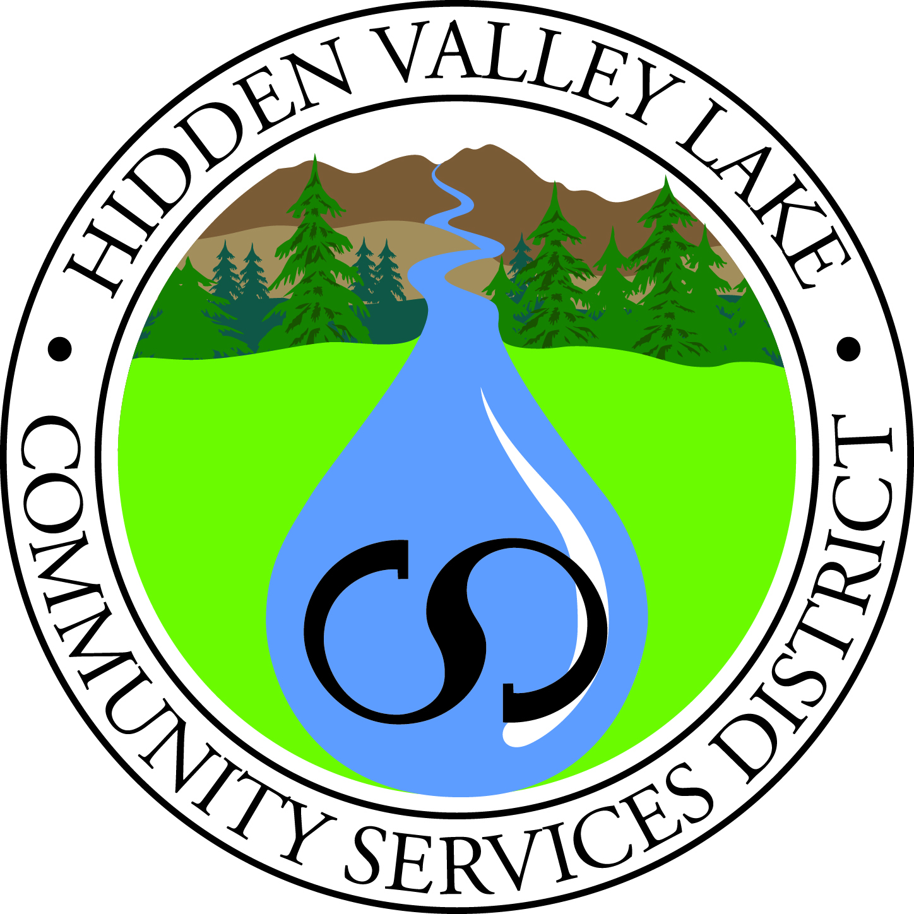
Hidden Valley Lake
Community Services District

19400 Hartmann Road
Hidden Valley Lake, CA 95467
707.987.9201
707.987.3237 fax
www.hiddenvalleylakecsd.com

Special Meeting
Strategic Plan Review Workshop

DATE: Saturday, January 23, 2016
TIME: 9 am
PLACE: Hidden Valley Lake CSD
Administration Office, Boardroom
19400 Hartmann Road
Hidden Valley Lake, CA

1) CALL TO ORDER
2) PLEDGE OF ALLEGIANCE
3) ROLL CALL
4) APPROVAL OF AGENDA

5) REVIEW GOALS, STRATEGIES AND INITIATIVES

6) UPDATE TO STRATEGIC PLAN DOCUMENT – CONTENT AND TIMEFRAME

10) PUBLIC COMMENT

11) ADJOURNMENT

Public records are available upon request. Board Packets are posted on our website at www.hiddenvalleylakecsd.com. Click on the “Board Packet” link on the Agenda tab.

In compliance to the Americans with Disabilities Act, if you need special accommodations to participate in or attend the meeting please contact the District Office at 987-9201 at least 48 hours prior to the scheduled meeting.

Public shall be given the opportunity to comment on each agenda item before the Governing Board acts on that item, G.C. 54953.3. All other comments will be taken under Public Comment.

